A six session plan for supporting weight loss:
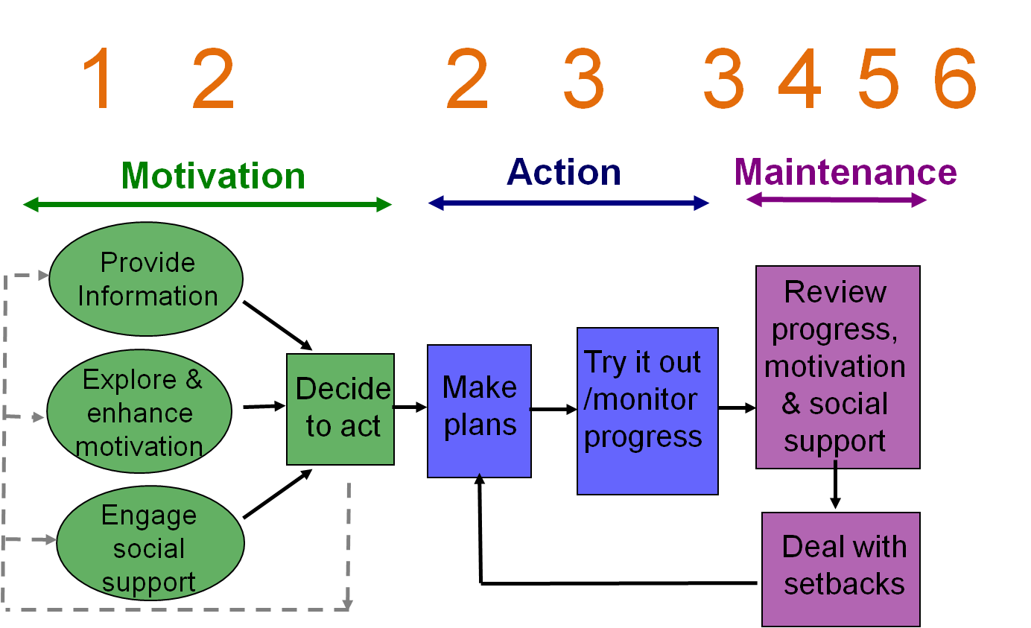

SUMMARY
Get people ready to make changes (Motivation)
Figure out what changes to make (Assessment)
Make Action Plans contain: 1) SMART-ER goals 2) coping and social support plan
Set up some self-monitoring to support their change
Give people time to put their plans into practice
Review progress, solve problems, revise plans
Use empathy building techniques throughout

Pre-Course screening /referral consultation:

RAISE THE SUBJECT and discuss the possible benefits of making a change in lifestyle. Provide some simple take-away materials that describe the benefits (not just health) of weight loss
- “Would you mind if we spend a few minutes talking about healthy eating and physical activity?”
- “I'm not here to tell you what to do - Use Reflective Listening and 'Roll with Resistance' to show that you understand their position and you are really not going to push them into anything
SCREENING - comparison with recommended BMI and physical activity levels (GPPAQ)
EXPLORE IMPORTANCE using brief motivational interviewing
- “What would be the benefits to you personally of losing some weight?”
- Reflect or reframe their responses to encourage PEP (Positive, Emotional and Personal) motivations
- “If you did decide to lose some weight, do you think you could do it and keep it off?"
- “What do you think you will do?”
REFERRAL
- IF they want to change with support, then facilitate this as per your practice's agreed pathway

Session 1: Getting started (20 mins)

1.1: Set the scene:
"My understanding is that we are here to discuss the idea of making some changes to your diet and maybe your physical activity levels in order to lose some weight - is that about right?"
Explain how the service works (by supporting you to get motivated, then to do some experiments to try and see what is going to work for you)
Do a 3-minute Ask-Tell-Discuss around what causes weight gain /weight loss (Energy Balance) and address any concerns (e.g. about metabolism) “What do you know about how people get to be over-weight – where does it come from?”

1.2: EXPLORE IMPORTANCE of weight loss (in general) using brief motivational interviewing
- “What would be the benefits to you personally of losing some weight?”
- Reflect or reframe their responses to encourage PEP (Positive, Emotional and Personal) motivations
- Exchange information (Ask-Tell-Discuss) if needed to reinforce benefits to build a 'functional understanding”. E.g. What do you know about how being overweight affects your heart over time?
- Record the main reason(s) for wanting to make a change (this will be useful later)

1.3: Explore confidence about a) making some changes to what you eat and b) finding some ways to increase your physical activity by 10 mins or so per day
- “On a scale of 1 to 10 how confident are you that ...” “Why not a higher score?”
Work to identify barriers and find possible solutions

1.4: Make a Summary of the Importance of weight loss to the patient and his .her Confidence about making changes in diet and physical activity.

1.5: The Turning Point: Ask "where does that leave you?" - Options are a) Stay the same (support their right to decide and 'leave the door open') b) Make some changes (go on to 1.7) c) Uncertain (review Importance and Confidence again.

1.6: Decide what to work on first:
- "The aim here is to try to find some simple changes that are easy for you to make and to keep going with, rather than any kind of drastic diet or exercise programme that is going to be hard to stick with. So, we are going to take it easy and take one step at a time - how does that sound?"
- “What would you like to work on first - changing what you eat or getting a bit more active?"

1.7: Introduce the assessment as a Take Away Task:- "To begin to plan any changes you first need to have a good idea about what is a healthy diet (or what kind of activity counts towards your health) and secondly, we need to know what you are doing at the moment”
- Either a) give a PA diary or ask them to think about what is a "typical week" in terms of PA so that you can discuss this next time. OR b) give a food assessment questionnaire or food diary to complete and bring back so that you can discuss it next time.

1.8: Summarise and provide information:
- "So you are going to make an assessment of what you are eating (or your PA) so that we can make a more detailed plan next week. We will talk again next time about what is a healthy lifestyle and how to make changes that you can live with. In the meantime ...
- Provide appropriate information and the ‘process of behaviour change’ diagram.

Session 2: Assessment and planning (10-15 mins)

Step 1: If they chose to work on Activity first:
- “How did you get on with the written material I gave you last time?”
Do a 5-minute Ask-Tell-Discuss around 'do you know what is the recommended amount of PA for health?' and "what counts as moderate physical activity".
Look at their physical activity diary (if completed) or review a "typical week" in terms of PA and discuss where they think they might be able to get a bit more (e.g. an extra 10 mins on 3 days of the week). Use a pick-list or offer your own suggestions to prompt them if needed (but it's better if they generate the ideas).

Step 1: If they chose to work on Diet first:
- “How did you get on with the written material I gave you last time?”
Do a 5-minute Ask-Tell-Discuss around what is a healthy diet (using the EatWell plate or other tool).
Look at their food diary if they have completed this or review a "typical day" or “3 or 4 meals that you eat regularly” and ask them to identify 2-3 small changes they think they might be able to make to make their diet more healthy. You can use a pick-list or offer your own suggestions to prompt them if needed (but it's better if they generate the ideas).

Step 2: Discuss their planned changes in more details to make them more specific (Where, When, How much, How often)
- "What might stop you from succeeding?"
- "What could you do to avoid this problem?" - you can offer your own suggestions to prompt them if needed, but it is much better if they can generate the ideas here.
- “Is there anyone else who could help you in some way?” – explore ideas about social support
- “How will you keep track of whether you are achieving your goals?” – set up self-monitoring

- Give them an action plan sheet to record their goals (they can take this away to complete). Explain why this can be useful – “it will help you to keep track of what you set out to do and will be useful and will save time when we come to reviewing your progress next time - we also know that people who make detailed plans are more likely to succeed in making these kind of changes”.
- It may be useful for you to also make some notes on their goals to refer back to next time.
NB: If they don’t want to write it down, you can do this verbally, or you can ask if you can write it down so you have a copy to keep with their notes.

Session 3: Making progress (15-20 mins)

Review progress:
- “How is it going?” What changes did you try? How did you get on with them?
Ask if they know their weight / if they want to be weighed

Reinforce success:
- “How do you feel about that?” - Reinforce any positive feelings
- “Do you feel that these changes are ones that you can live with?”

Manage setbacks:
Re-frame setbacks as being perfectly normal and part of the learning experience
- “The main thing is to learn from your experiences – over time you will figure out what works or doesn’t work for you”

Problem-solve
- “What stopped you from succeeding?”
- “What could do differently to get around these problems?”

Review motivations:
- “Can you still see some strong reasons for wanting to lose weight?”

Review the action plan:
- “Anything you want to change or add to your plan?”
- “Do you want to go further?”
- “How are you monitoring your progress?” (e.g. pedometer; food or activity diaries, daily weighing)
- Check their social support

Add the other behaviour (PA or diet)
If they are on the diet-first pathway, remind them about the energy balance and ask if they are willing to start working on the physical activity as well. If they are on the activity-first pathway, remind them about the energy balance and ask if they are willing to start working on the physical activity as well.
Introduce the assessment as a Take Away Task:
- "To begin to plan any changes, first you need to have a good idea about what is a healthy diet (or what kind of activity counts towards your health) and secondly, we need to know what you are doing at the moment. Then we can work out what is going to fit easily into your life”
- Either a) give a PA diary or ask them to think about what is a "typical week" in terms of PA so that you can discuss this next time. OR b) give a food assessment questionnaire or food diary to complete and bring back so that you can discuss it next time.
- Provide appropriate information

Throughout: Exchange more information (Ask-Tell-Discuss) about diet and physical activity as needed - advancing their knowledge a bit at a time.

Session 4 (15-20 mins)

Briefly review progress with the first behaviour (diet or PA):
- “How is it going?”
Ask if they want to be weighed

Reinforce success:
- “How do you feel about that?” - Reinforce any positive feelings
- “Do you feel that these changes are ones that you can live with?”

Manage setbacks:
Re-frame setbacks as being perfectly normal and part of the learning experience
- “The main thing is to learn from your experiences”

Problem-solve
- “What stopped you from succeeding?”
- “What could do differently to get around these problems?”

Review the action plan:
- “Anything you want to change or add to your plan?”

Assess and plan action for the ‘other’ behaviour (PA or diet)
Step 1: ASSESSMENT
- “How did you get on with the written material I gave you last time?”
Do a 5-minute Ask-Tell-Discuss around EITHER 'do you know what is the recommended amount of PA for health?' and "what counts as moderate physical activity". OR ‘what is a healthy diet?’
Look at their physical activity or food diary (if completed) or review a "typical week" (for PA) or “3 or 4 meals that you eat regularly” (for DIET)
Discuss what they think they might be able to change to make their lifestyle more healthy. Use a pick-list or offer your own suggestions to prompt them if needed (but it's better if they generate the ideas).

Step 2: ACTION PLANNING
Discuss their planned changes in more details to make them more specific (Where, When, How much, How often)
- "What might stop you from succeeding?"
- "What could you do to avoid this problem?" - you can offer your own suggestions to prompt them if needed, but it is much better if they can generate the ideas here.
- “Is there anyone else who could help you in some way?” – explore ideas about social support
- “How will you keep track of whether you are achieving your goals?” – set up self-monitoring

- Provide an action plan sheet to record their goals (they can take this away to complete). Explain why this can be useful – “it will help you to keep track of what you set out to do and will be useful and will save time when we come to reviewing your progress next time”
- It may be useful for you to also make some notes on their goals to refer back to next time.

Throughout: Exchange more information (Ask-Tell-Discuss) about diet and physical activity as needed - advancing their knowledge a bit at a time.
Session 5, 6: Keeping going (10-15 mins)

Review progress: (for both diet and physical activity)
- “How is it going?” What changes did you try? How did you get on with them?
Ask if they know their weight / if they want to be weighed

Reinforce success:
- “How do you feel about that?” - Reinforce any positive feelings
- “Do you feel that these changes are ones that you can live with?”

Manage setbacks:
Re-frame setbacks as being perfectly normal and part of the learning experience
- “The main thing is to learn from your experiences – over time you will figure out what works or doesn’t work for you”

Problem-solve
- “What stopped you from succeeding?”
- “What could do differently to get around these problems?”

Review motivations:
- “Can you still see some strong reasons for wanting to lose weight?”

Review the action plan:
- “Anything you want to change or add to your plan?”
- “Do you want to go further?”

Throughout:
- Aim to build up a set of small changes until they are losing weight (or achieving at least 150 mins of PA per week).
- Exchange information as needed to help them problem-solve (identify barriers and possible solutions), including impulse control and social support. Encourage them to figure out what works for them.
- Over sessions 5-6 you can introduce ideas of 'keeping the ball rolling /hitting a plateau' and setting longer-term targets
- Periodically it may be useful to review other risk markers (e.g. blood pressure, blood glucose)

Skills for supporting behaviour change

- Empathy building: The Guiding style; Open-ended questions; Affirmation; Reflective Listening; Rolling with Resistance;
- Assessment: Typical day; dietary and PA assessment tools
- Exchanging information: Ask-Tell-Discuss
- Exploring motivation: (Importance plus Confidence): Decisional balance; Two futures; Confidence Ruler; Summaries
- Action planning: SMART-ER goals. Coping and social support plans.
- Self-regulation techniques: (Learning from experience): Using feedback; Self-monitoring; Re-framing failure; Problem-solving
- Managing emotional processes: Encouraging enjoyment of lifestyle; managing food cravings

