Website Statistics: 07 August 2012 to 06 September 2012
www.devonhealthandwellbeing.org.uk
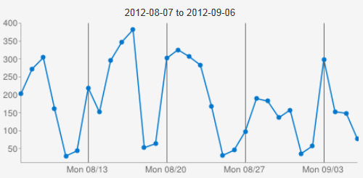

Summary Statistics
1,582 Unique Visits
5,433 Page Views
Average 3.43 Pages per Visit

Top Pages (100+ Views)
Rank | Page | Views
1 | Survey Introduction Page | 952
2 | Homepage | 570
3 | Shadow Health and Wellbeing Board | 325
4 | Maps | 283
5 | Health and Wellbeing Strategies | 281
6 | Board Members | 249
7 | Survey Form: Individual | 240
8 | Joint Strategic Needs Assessment | 230
9 | Health and Wellbeing Library | 162
10 | JSNA Community Profiles | 133
11 | Survey Form: Organisation | 119

Top Referrers
Rank | Page | Visits
1 | Direct Access (no referrer) | 666
2 | www.google.co.uk | 483
3 | www.devon.gov.uk | 162
4 | www.devonnewscentre.info | 46
5 | http://www.bing.com/?cc=gb | 28
6 | http://uk.yahoo.com/ | 25

